FINANCIAL ANALYSIS PORTFOLIO
Samsung Electronics Co., Ltd.
Financial Performance, Resilience and Business-Segment Analysis, 2022 to 2025
Central question: how did Samsung's financial performance change between 2022 and 2025, what drove the 2023 shock and the recovery, and what vulnerabilities remain?
Final Report and Methodology
Prepared by: Sanzida Kabir
September 2026
Data basis: consolidated financial statements (K-IFRS), KRW, FY2022 to FY2025
Descriptive analysis for portfolio and educational purposes. Not investment advice.

1. Executive Summary
This report analyses the consolidated financial performance of Samsung Electronics Co., Ltd. over fiscal years 2022 to 2025. It examines profitability, financial position, cash generation, efficiency and business-segment performance, using audited and reviewed consolidated financial statements published by the company. The central question is: how did Samsung's financial performance change between 2022 and 2025, what drove the sharp deterioration in 2023 and the recovery that followed, and what vulnerabilities remain despite that recovery?
Central finding. Samsung's profits fell far faster than its revenue in 2023 (revenue −14.3%, operating profit −84.9%) and then recovered strongly. By 2025 operating profit (KRW 43.6 trillion) was back at its 2022 level (KRW 43.4 trillion) and free cash flow was well above 2022. However, net income remained 18.8% below 2022, the operating margin (13.1%) was still below 2022 (14.4%), and liquidity, liabilities-to-equity, cost intensity and asset productivity all moved in a less favourable direction than in 2022. The recovery is real, but it is not a return to the 2022 position on every measure.
Table 1: Key metrics, FY2022 to FY2025
Metric | 2022 | 2023 | 2024 | 2025
Revenue (KRW trillion) | 302.2 | 258.9 | 300.9 | 333.6
Operating profit (KRW trillion) | 43.4 | 6.6 | 32.7 | 43.6
Net income (KRW trillion) | 55.7 | 15.5 | 34.5 | 45.2
Operating margin | 14.4% | 2.5% | 10.9% | 13.1%
Net margin | 18.4% | 6.0% | 11.5% | 13.6%
Free cash flow (KRW trillion) | 12.8 | −13.5 | 21.6 | 37.8
Current ratio | 2.79x | 2.59x | 2.43x | 2.33x
Liabilities-to-equity | 26.4% | 25.4% | 27.9% | 29.9%
Source: Samsung Electronics consolidated financial statements; author's calculations (workbook sheets 01 to 07).
Headline findings
- A severe, earnings-led shock in 2023. Revenue fell 14.3%, but gross profit fell 30.0%, operating profit 84.9% and net income 72.2%. The operating margin dropped from 14.4% to 2.5%.
- A strong recovery, complete at the operating level but not at the net level. 2025 revenue was +10.4% versus 2022 and operating profit +0.5%, but net income was −18.8%. Net income exceeded operating profit in 2022 (KRW 55.7 trillion versus 43.4 trillion), so part of the 2022 result came from non-operating items that this study does not decompose.
- Costs grew faster than sales. Gross margin improved to 39.4% (2022: 37.1%), yet selling and administrative expenses rose +27.5% against revenue growth of +10.4%, lifting SG&A from 22.8% to 26.3% of revenue. This is why the operating margin has not fully recovered.
- Cash generation recovered strongly. Free cash flow moved from KRW 12.8 trillion (2022) to −13.5 trillion (2023, negative) and KRW 37.8 trillion (2025), as operating cash flow rose and capital expenditure eased.
- The balance sheet remains strong but the cushion is narrowing. The current ratio declined every year (2.79x to 2.33x), and liabilities-to-equity rose from 26.4% to 29.9%. Both remain conservative in absolute terms.
- Growth is increasingly semiconductor-led. Between 2023 and 2025, DS division sales rose +95.3%, versus +10.6% for DX and −3.9% for SDC. DS's share of divisional sales rose from 23.6% to 35.8%, measured from the 2023 trough.
- Assets grew much faster than revenue. Total assets rose +26.4% and trade receivables +43.1% between 2022 and 2025, against revenue growth of +10.4%. Year-end asset turnover fell from 0.67x to 0.59x.
Bottom line. Samsung's 2025 position is financially strong. The more useful analytical question is how sustainable and resilient that position is. The evidence points to continued exposure to the semiconductor cycle, rising cost intensity, and a gradual erosion of liquidity and asset productivity relative to 2022. The report proposes measures in four areas: earnings resilience, working-capital and liquidity management, capital allocation and cost discipline, and strengthening slower-growing businesses. These are analytical suggestions derived from the data, not investment advice.
2. Introduction
2.1 Company background
Samsung Electronics Co., Ltd. is a Korean multinational electronics and semiconductor group. Its financial statements, prepared under Korean International Financial Reporting Standards (K-IFRS), report four business divisions:
- DX (Device eXperience): digital TVs, refrigerators and other appliances, mobile phones and communication systems.
- DS (Device Solutions): memory, foundry and system LSI semiconductors.
- SDC (Samsung Display): display panels.
- Harman: connected-car systems, audio and visual products, enterprise automation solutions and connected services.
The group is heavily exposed to the semiconductor cycle through DS, and to consumer-electronics demand through DX and SDC. That combination makes the 2022 to 2025 period, which spans a strong year, a downturn and a recovery, a useful case study in earnings volatility.
2.2 Research question and objectives
Central research question. How did Samsung Electronics' financial performance change between 2022 and 2025, what caused the sharp deterioration in 2023 and the subsequent recovery, and what financial and operational vulnerabilities remain despite the recovery?
The study addresses six sub-questions:
- How did revenue, gross profit, operating profit and net income change from year to year?
- How did profitability and the cost structure change, and what explains the 2023 shock?
- How did liquidity, leverage and efficiency evolve?
- How did operating cash flow, capital expenditure and free cash flow behave through the cycle?
- How did the mix of divisions and regions change between 2023 and 2025?
- Which vulnerabilities and opportunities does the evidence reveal, and what responses are suggested?
2.3 Scope
The analysis covers Samsung's consolidated results for the fiscal years ended 31 December 2022, 2023, 2024 and 2025. All amounts are in Korean won (KRW). The study is descriptive and diagnostic. It does not forecast, value the company, compare Samsung with peers, or recommend any investment decision.
3. Data and Methodology
3.1 Research design
The study is a longitudinal, single-company case study based on published financial statements. It combines four standard techniques of financial-statement analysis: common-size analysis, year-over-year growth and compound annual growth (CAGR), ratio analysis, and cash-flow analysis. Segment and geographic disclosures add a business-mix perspective. Each technique is implemented with live formulas in the accompanying Excel workbook so that every figure in this report can be traced to a source cell.
3.2 Data sources
All financial data come from Samsung Electronics' own Investor Relations disclosures. No third-party aggregators were used.
Table 2: Source documents by statement and year
Data | Years | Source document | Note
Income statement | 2022 | FY2022 consolidated statements of profit or loss (2022_con_quarter04_soi_1.pdf) | Audited
Income statement | 2023 to 2024 | FY2024 consolidated financial statements, with 2023 comparatives | Audited
Income statement | 2025 | FY2025 statements of profit or loss (2025_con_quarter04_soi.pdf) | Annual release
Balance sheet | 2022 | 31 Dec 2022 comparative column, Q1 2023 interim statements (2023_con_quarter01_all.pdf) | Reviewer states it is not different from the audited statement
Balance sheet | 2023 to 2025 | FY2024 statements; FY2025 statements of financial position (2025_con_quarter04_bs.pdf) | Audited / annual release
Cash flow | 2022 | FY2022 consolidated statements of cash flows, Korean-language filing (2022_con_quarter04_cf.pdf) | Original Korean text
Cash flow | 2023 to 2025 | FY2024 statements; FY2025 statements of cash flows (2025_con_quarter04_cf.pdf) | Audited / annual release
Divisional and regional sales | 2023 to 2025 | Samsung Sustainability, Facts & Figures page | KRW trillion; not available for 2022
Full URLs are listed in Appendix C.
3.3 Data collection and validation
Values were transcribed from the filings into the workbook in KRW millions, the unit used in Samsung's statements, and each input cell carries a note naming its source document. The following integrity checks were applied and passed:
- Revenue less cost of sales equals gross profit, and gross profit less selling and administrative expenses equals operating profit.
- Current plus non-current assets equals total assets; current plus non-current liabilities equals total liabilities; total liabilities plus total equity equals total assets.
- Net income on the income statement equals the opening profit line of the cash-flow statement in all four years, and FY2022 year-end cash on the cash-flow statement equals cash and cash equivalents on the balance sheet.
- Samsung's own disclosed "debt ratio" at 31 December 2022, defined as total liabilities divided by total equity, is 26.4%. The workbook's liabilities-to-equity ratio for 2022 is 26.4%, which matches.
- Regional sales for 2023 to 2025 sum to consolidated revenue within rounding (KRW 258.9, 300.8 and 333.6 trillion against reported revenue of 258.9, 300.9 and 333.6 trillion).
3.4 Metric definitions
Table 3: Metrics and formulas
Metric | Formula | Comment
Gross margin | Gross profit / Revenue
Operating margin | Operating profit / Revenue
Net margin | Net income / Revenue | Net income is profit for the year, including non-controlling interests
Common-size item | Line item / Revenue | Income-statement structure
YoY growth | (Current year - Prior year) / Prior year
CAGR | (Ending / Beginning)^(1/n) - 1 | n = 3 years for 2022 to 2025
Current ratio | Current assets / Current liabilities
Quick ratio | (Current assets - Inventories) / Current liabilities | Conservative form
Liabilities-to-assets | Total liabilities / Total assets | Not interest-bearing debt
Liabilities-to-equity | Total liabilities / Total equity | Equals Samsung's own 'debt ratio'
ROA, ROE | Net income / Total assets (or equity) | Year-end basis; average basis in Table 10
Asset turnover | Revenue / Total assets | Year-end basis; average basis in Table 10
Inventory turnover | Cost of sales / Inventories
Receivables turnover | Revenue / Trade receivables
Free cash flow | Operating cash flow - Acquisition of PP&E | Excludes intangible-asset purchases
Cash conversion | Operating cash flow / Net income
Capex intensity | Acquisition of PP&E / Revenue
3.5 Conventions and treatment decisions
- Primary ratios use year-end balances so that all four years are comparable. Average-balance versions of ROA, ROE and the turnover ratios are shown in Section 8 for 2023 to 2025; a 2022 average would require the 2021 balance sheet, which is outside the dataset.
- Leverage is measured on total liabilities, not on interest-bearing debt, because borrowings were not separately extracted. The ratios are therefore labelled liabilities-to-assets and liabilities-to-equity.
- Divisional sales are before intercompany eliminations. The four divisions sum to KRW 363.7 trillion in 2025 against consolidated revenue of KRW 333.6 trillion. Samsung's interim segment note shows the difference as an intercompany reconciliation. Mix percentages are therefore shares of the divisional total, not of consolidated revenue.
- Rounding. Narrative figures are rounded to one decimal place in KRW trillion; all calculations use unrounded KRW millions.
4. Revenue and Earnings Performance
Revenue moved from KRW 302.2 trillion in 2022 to KRW 258.9 trillion in 2023, then rebounded to KRW 300.9 trillion in 2024 and KRW 333.6 trillion in 2025. Over the three years to 2025 revenue grew at a compound rate of 3.3% a year, a modest figure that conceals a deep dip and a sharp rebound in between.
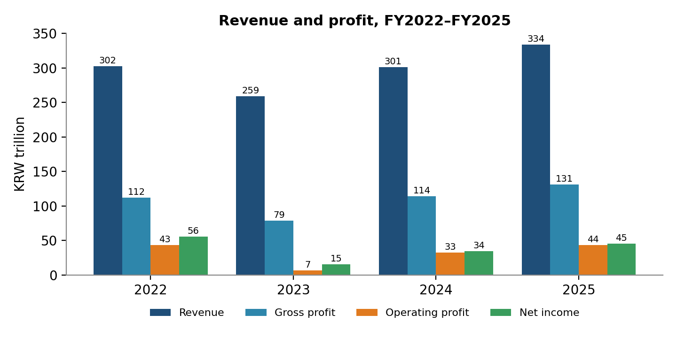
Figure 1: Revenue and profit, FY2022 to FY2025 (KRW trillion). Source: Samsung consolidated financial statements; author's calculations.
Table 4: Income statement summary (KRW trillion)
Line item | 2022 | 2023 | 2024 | 2025
Revenue | 302.2 | 258.9 | 300.9 | 333.6
Cost of sales | 190.0 | 180.4 | 186.6 | 202.2
Gross profit | 112.2 | 78.5 | 114.3 | 131.4
Selling and administrative expenses | 68.8 | 72.0 | 81.6 | 87.8
Operating profit | 43.4 | 6.6 | 32.7 | 43.6
Net income | 55.7 | 15.5 | 34.5 | 45.2

Table 5: Year-over-year growth
Line item | 2023 | 2024 | 2025 | 2025 vs 2022
Revenue | −14.3% | +16.2% | +10.9% | +10.4%
Gross profit | −30.0% | +45.5% | +14.9% | +17.1%
Operating profit | −84.9% | +398.3% | +33.2% | +0.5%
Net income | −72.2% | +122.5% | +31.2% | −18.8%
2022 growth is not shown because 2021 data are outside the dataset.
4.1 The 2023 shock
The defining feature of 2023 is not the fall in revenue but the disproportionate collapse in profit. A 14.3% decline in revenue was accompanied by a 30.0% decline in gross profit and an 84.9% decline in operating profit. Operating profit fell from KRW 43.4 trillion to KRW 6.6 trillion. This indicates high operating leverage: a large share of Samsung's cost base is fixed or slow to adjust, so a moderate fall in sales, combined with weaker pricing, removes most of the profit.
The divisional data point to the semiconductor business as the main source of the shock. In Samsung's Q1 2023 interim statements, the DS division reported an operating loss of KRW 4.6 trillion, against an operating profit of KRW 8.5 trillion in Q1 2022, while DX remained profitable in both periods. DS sales then rebounded strongly: they were KRW 66.6 trillion in 2023 and KRW 111.1 trillion in 2024, an increase of +66.8%. That pattern is consistent with a cyclical downturn in the semiconductor business rather than a company-wide loss of demand, although this report does not model the cycle directly.
4.2 The recovery
Recovery began in 2024, when revenue grew +16.2% and operating profit rose +398% from a very low base. In 2025 revenue grew a further +10.9% and operating profit +33.2%, reaching KRW 43.6 trillion, marginally above the 2022 level (+0.5%).
Net income tells a different story. It reached KRW 45.2 trillion in 2025 but remained 18.8% below the 2022 figure of KRW 55.7 trillion, and its three-year CAGR is −6.7%. In 2022 net income was larger than operating profit, which implies that non-operating items (for example finance income, associates and tax effects) added materially to that year's result. A decomposition of those items would be a worthwhile extension of this study.
5. Profitability and Cost Structure
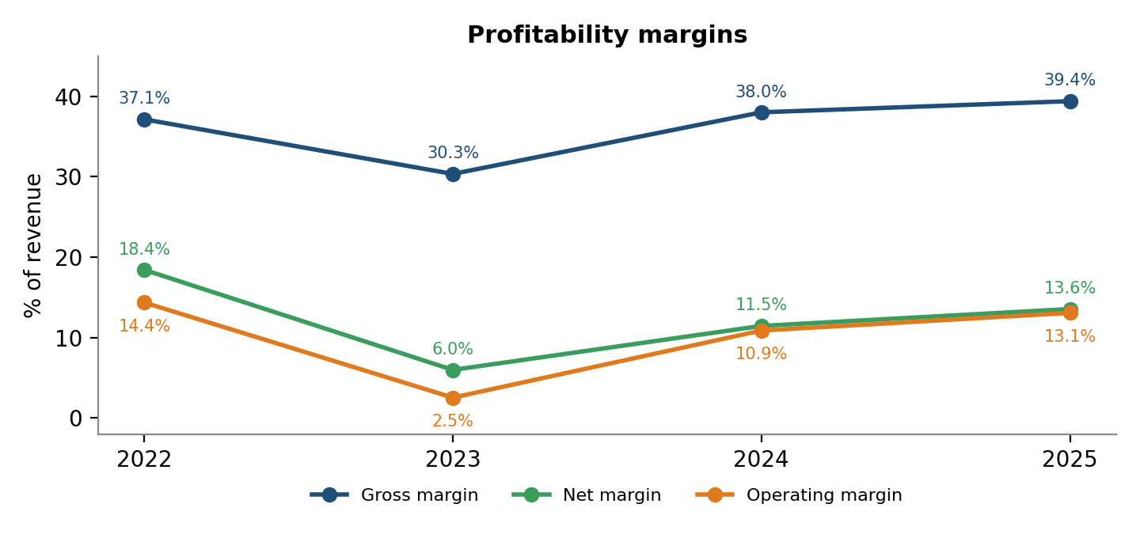
Figure 2: Gross, operating and net margins, FY2022 to FY2025. Source: author's calculations from Samsung consolidated financial statements.
Table 6: Common-size income statement (% of revenue)
Line item | 2022 | 2023 | 2024 | 2025
Cost of sales | 62.9% | 69.7% | 62.0% | 60.6%
Gross profit | 37.1% | 30.3% | 38.0% | 39.4%
Selling and administrative expenses | 22.8% | 27.8% | 27.1% | 26.3%
Operating profit | 14.4% | 2.5% | 10.9% | 13.1%
Net income | 18.4% | 6.0% | 11.5% | 13.6%

Gross margin fell from 37.1% in 2022 to 30.3% in 2023, as cost of sales rose to 69.7% of revenue. It then recovered to 38.0% in 2024 and 39.4% in 2025, above the 2022 level. On gross margin alone, Samsung has more than recovered.
The operating margin has not followed. Selling and administrative expenses were 22.8% of revenue in 2022, rose to 27.8% in 2023 as revenue fell, and were still 26.3% in 2025. In absolute terms these expenses grew from KRW 68.8 trillion to KRW 87.8 trillion (+27.5%), more than two and a half times the +10.4% growth in revenue. Samsung reports research and development expense within selling and administrative expenses, so part of this growth reflects R&D investment rather than overhead. Samsung's fourth-quarter 2025 results release describes record full-year R&D spending of KRW 37.7 trillion. Even so, the effect is that a 2.3 percentage-point gain in gross margin (from 37.1% to 39.4%) was more than absorbed by a 3.5 percentage-point rise in SG&A intensity, leaving the 2025 operating margin (13.1%) about 1.3 points below 2022 (14.4%).
Interpretation. Profitability has recovered because of a better gross margin, not because of cost leverage. Whether the higher SG&A base is a sound investment in future competitiveness or a structural drag on margins cannot be settled from consolidated data alone; it depends on the return on R&D and marketing spending.
6. Financial Position: Liquidity and Leverage
Table 7: Balance sheet summary (KRW trillion, year-end)
Line item | 2022 | 2023 | 2024 | 2025
Cash and cash equivalents | 49.7 | 69.1 | 53.7 | 57.9
Trade receivables | 35.7 | 36.6 | 43.6 | 51.1
Inventories | 52.2 | 51.6 | 51.8 | 52.6
Total current assets | 218.5 | 195.9 | 227.1 | 247.7
Total assets | 448.4 | 455.9 | 514.5 | 566.9
Total current liabilities | 78.3 | 75.7 | 93.3 | 106.4
Total liabilities | 93.7 | 92.2 | 112.3 | 130.6
Total equity | 354.7 | 363.7 | 402.2 | 436.3

6.1 Liquidity
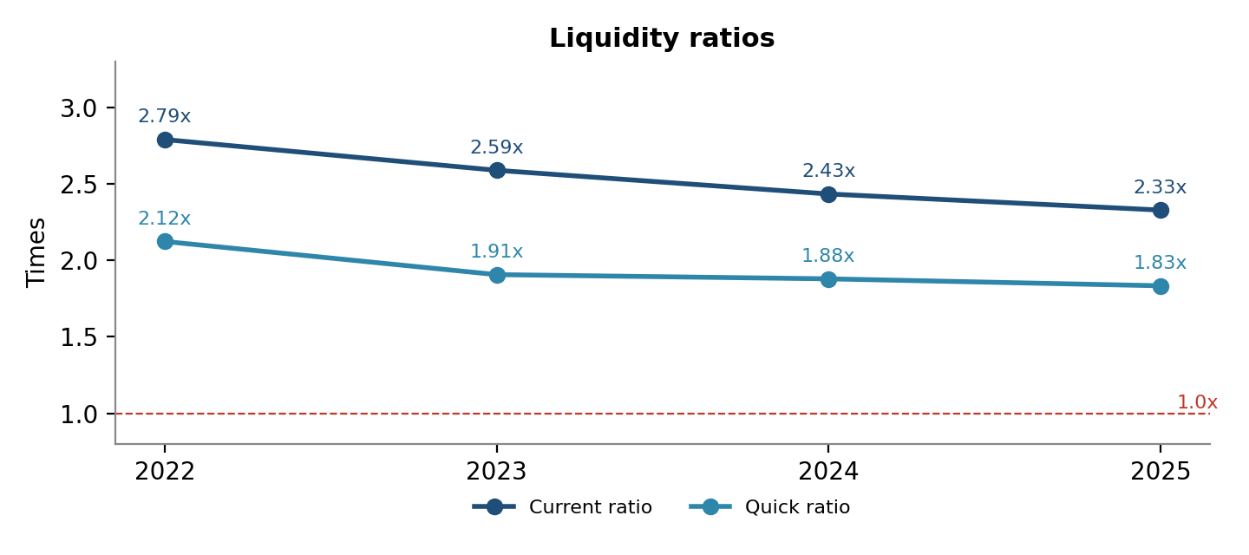
Figure 3: Current and quick ratios, FY2022 to FY2025. Source: author's calculations.
The current ratio declined in each year, from 2.79x in 2022 to 2.33x in 2025, and the quick ratio from 2.12x to 1.83x. The cause is visible in the balance sheet: between 2022 and 2025 current assets grew +13.4%, while current liabilities grew +35.8%. Both ratios remain far above 1.0, and cash and cash equivalents were +16.5% higher than in 2022, so the data do not indicate any liquidity stress. The accurate description is a gradual narrowing of a very large cushion.
6.2 Leverage
Table 8: Leverage ratios
Ratio | 2022 | 2023 | 2024 | 2025
Liabilities-to-assets | 20.9% | 20.2% | 21.8% | 23.0%
Liabilities-to-equity | 26.4% | 25.4% | 27.9% | 29.9%

Total liabilities grew +39.4% between 2022 and 2025 while equity grew +23.0%, so liabilities-to-equity rose from 26.4% to 29.9%, with a dip in 2023. The balance sheet is still predominantly equity-funded: liabilities were only 23.0% of total assets in 2025. These ratios use total liabilities, which include operating items such as payables and accrued expenses, so they overstate financial debt. A refinement using interest-bearing borrowings would sharpen this analysis.
7. Cash Flow and Capital Expenditure
Table 9: Cash flow summary (KRW trillion)
Line item | 2022 | 2023 | 2024 | 2025
Net cash from operating activities | 62.2 | 44.1 | 73.0 | 85.3
Net cash used in investing activities | −31.6 | −16.9 | −85.4 | −68.5
Acquisition of PP&E (capital expenditure) | −49.4 | −57.6 | −51.4 | −47.5
Net cash used in financing activities | −19.4 | −8.6 | −7.8 | −13.5
Free cash flow (operating cash flow less capex) | 12.8 | −13.5 | 21.6 | 37.8
Cash conversion (operating cash flow / net income) | 1.12x | 2.85x | 2.12x | 1.89x
Capex intensity (capex / revenue) | 16.4% | 22.2% | 17.1% | 14.2%

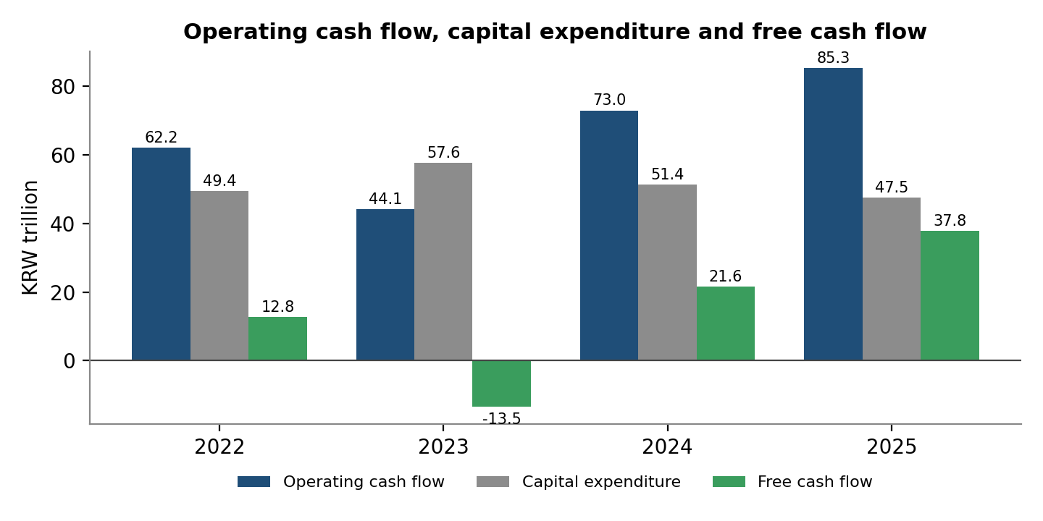
Figure 4: Operating cash flow, capital expenditure and free cash flow (KRW trillion). Source: Samsung consolidated statements of cash flows; author's calculations.
Cash flow shows how the cycle was financed. In 2023 operating cash flow fell 29.0% to KRW 44.1 trillion, yet capital expenditure rose +16.6% to KRW 57.6 trillion. Capex intensity reached 22.2% of revenue, and free cash flow turned negative at KRW −13.5 trillion. Samsung kept investing through the downturn rather than cutting spending in line with revenue.
The position reversed quickly. By 2025 operating cash flow was KRW 85.3 trillion, capex had eased to KRW 47.5 trillion (14.2% of revenue), and free cash flow reached KRW 37.8 trillion, roughly three times the 2022 figure. Cash conversion was well above 1.0x in every year, meaning cash generation exceeded reported profit, which is a sign of earnings quality, although in 2023 the ratio (2.85x) was inflated by the depressed net income.
Two context points are worth noting. First, cash and cash equivalents nonetheless rose in 2023 because the cash-flow statement shows a net decrease of KRW 39.4 trillion in short-term financial instruments during the year, so the company drew on liquid reserves held outside the cash line. Second, in financing activities Samsung paid dividends of roughly KRW 9.8 to 10.9 trillion in each year and, in the two most recent years, repurchased KRW 1.8 trillion (2024) and KRW 8.2 trillion (2025) of treasury shares. These items are taken from the financing section of the filings and are not tabulated in the workbook.
Free cash flow here deducts only purchases of property, plant and equipment. Purchases of intangible assets (for example KRW 3.7 trillion in 2022) are excluded, so the measure is slightly generous.
8. Efficiency and Asset Productivity
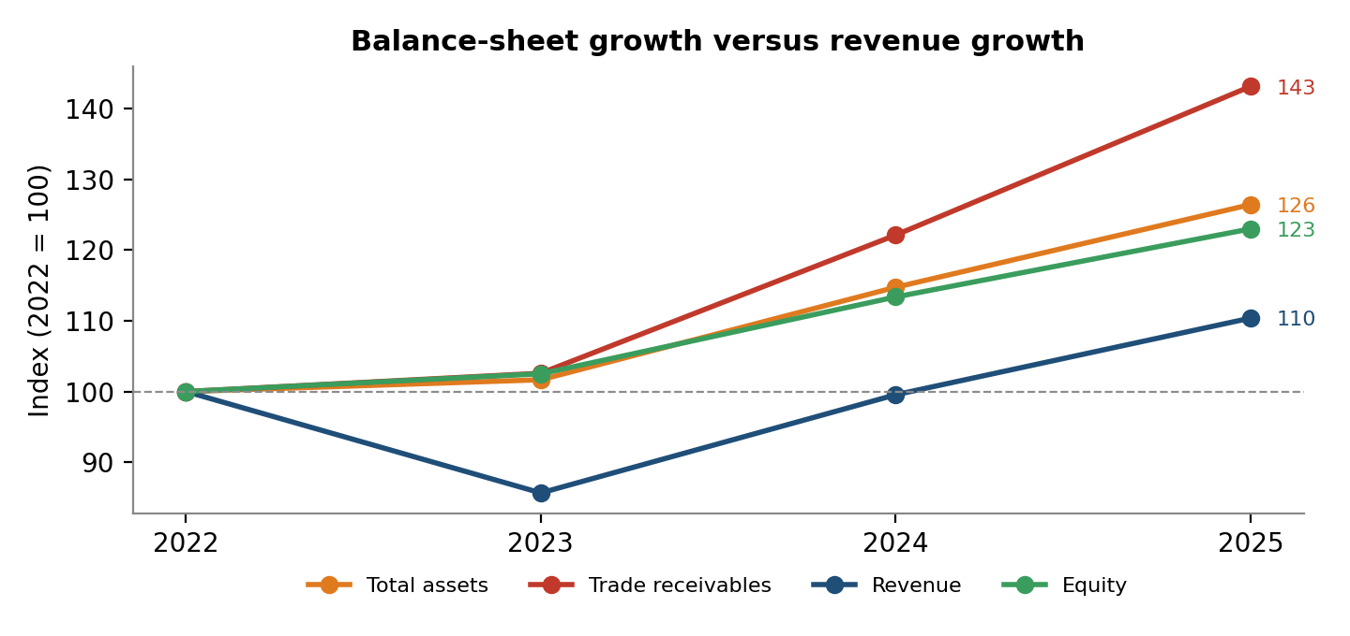
Figure 5: Total assets, trade receivables, revenue and equity indexed to 2022 = 100. Source: author's calculations.
Figure 5 shows the central efficiency issue. Between 2022 and 2025 total assets grew +26.4% and trade receivables +43.1%, while revenue grew only +10.4%. Equity grew +23.0%. The company's balance sheet has expanded substantially faster than the sales it supports.
Table 10: Efficiency and return ratios, year-end and average-balance bases
Ratio | 2022 | 2023 | 2024 | 2025
Asset turnover, year-end | 0.67x | 0.57x | 0.58x | 0.59x
Asset turnover, average balances | n/a | 0.57x | 0.62x | 0.62x
Receivables turnover, year-end | 8.46x | 7.07x | 6.90x | 6.52x
Receivables turnover, average balances | n/a | 7.16x | 7.50x | 7.04x
Inventory turnover, year-end | 3.64x | 3.49x | 3.60x | 3.84x
Inventory turnover, average balances | n/a | 3.48x | 3.61x | 3.87x
ROA, year-end | 12.4% | 3.4% | 6.7% | 8.0%
ROA, average balances | n/a | 3.4% | 7.1% | 8.4%
ROE, year-end | 15.7% | 4.3% | 8.6% | 10.4%
ROE, average balances | n/a | 4.3% | 9.0% | 10.8%
Average-balance ratios use the mean of opening and closing balances and start in 2023 because the 2021 balance sheet is outside the dataset. The average-balance rows are computed for this report and are not yet in the Excel workbook.
On a year-end basis, asset turnover fell from 0.67x in 2022 to 0.57x in 2023 and reached only 0.59x in 2025, and receivables turnover fell from 8.46x to 6.52x. The average-balance view is more measured: asset turnover stabilised near 0.62x in 2024 and 2025, and receivables turnover moved within a narrow 7.04x to 7.50x band. Year-end ratios also reflect timing. Strong fourth-quarter sales lift year-end receivables relative to full-year revenue. The receivables finding is therefore best treated as a watch item: trade receivables have clearly grown faster than revenue, but this study cannot separate deteriorating collection from year-end sales timing without quarterly data or days-sales-outstanding figures.
Return measures improved on both bases. On average balances ROA rose from 3.4% in 2023 to 8.4% in 2025, and ROE from 4.3% to 10.8%. On the year-end basis both remain below their 2022 levels (ROA 12.4%, ROE 15.7%), consistent with net income not having fully recovered.
9. Segment and Geographic Analysis
Divisional and regional sales are available from Samsung's Facts & Figures disclosure for 2023 to 2025 only. Because 2023 was the trough year, growth and share changes measured from 2023 overstate structural change: part of what looks like a shift toward DS is recovery from a depressed base.
9.1 Divisions
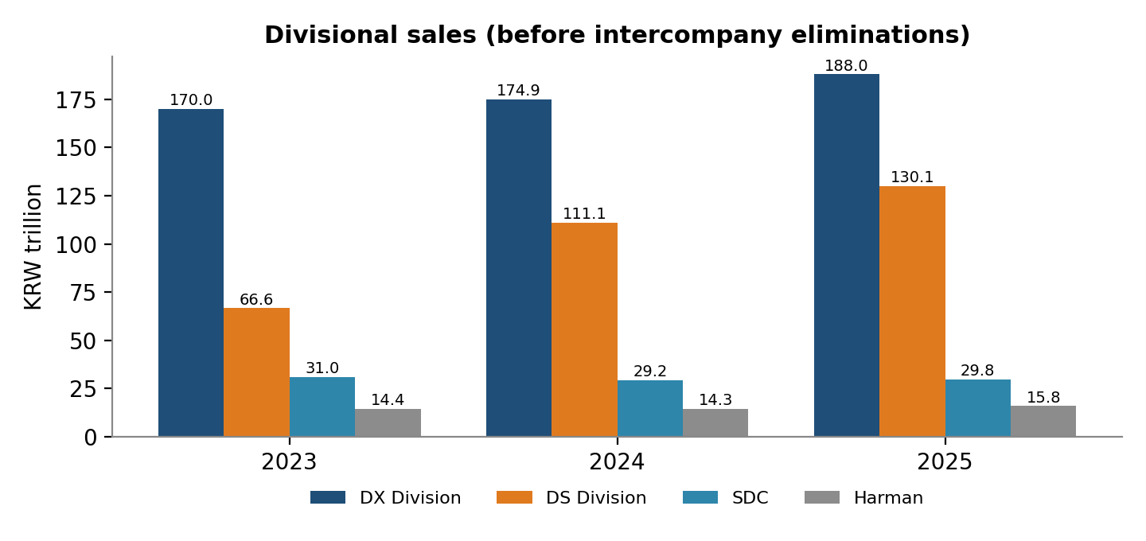
Figure 6: Divisional sales, 2023 to 2025 (KRW trillion, before intercompany eliminations). Source: Samsung Facts & Figures.
Table 11: Divisional sales, growth and mix
Division | 2023 (KRW tn) | 2025 (KRW tn) | Change 2023 to 2025 | Share 2023 | Share 2025
DX Division | 170.0 | 188.0 | +10.6% | 60.3% | 51.7%
DS Division | 66.6 | 130.1 | +95.3% | 23.6% | 35.8%
SDC | 31.0 | 29.8 | −3.9% | 11.0% | 8.2%
Harman | 14.4 | 15.8 | +9.7% | 5.1% | 4.3%
Total (before eliminations) | 282.0 | 363.7 | +29.0% | 100.0% | 100.0%
Divisional totals exceed consolidated revenue (KRW 333.6 trillion in 2025) by KRW 30.1 trillion because of intercompany sales between divisions.

- DS is the growth engine. DS sales rose from KRW 66.6 trillion to KRW 130.1 trillion (+95%), lifting its share of divisional sales from 23.6% to 35.8%. This concentrates the group's earnings exposure in the semiconductor cycle.
- DX is the largest division but grows more slowly. DX sales grew +10.6% over the two years and its share fell from 60.3% to 51.7%. It still accounts for over half of divisional sales.
- SDC has not grown. SDC sales were KRW 29.8 trillion in 2025, 3.9% below 2023, while the group recovered strongly. Its share fell from 11.0% to 8.2%.
- Harman is small and steady. Sales rose +9.7% to KRW 15.8 trillion, about 4.3% of divisional sales.
The dataset contains divisional sales only, not divisional operating profit, so profitability by division cannot be compared. That is the most important gap in the segment analysis, because DS and DX differ greatly in margin structure.
9.2 Regions
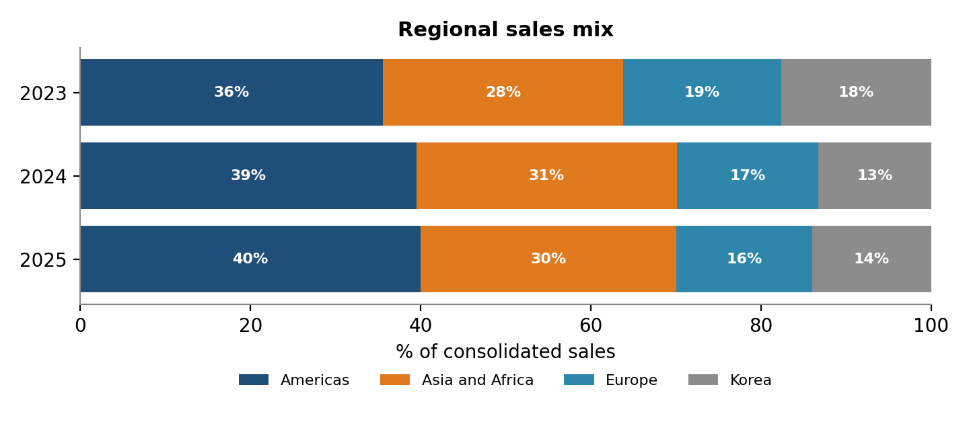
Figure 7: Regional sales mix, 2023 to 2025. Source: Samsung Facts & Figures; author's calculations.
Table 12: Regional sales and growth
Region | 2023 (KRW tn) | 2025 (KRW tn) | Change 2023 to 2025 | Share 2025
Americas | 92.1 | 133.3 | +44.7% | 40.0%
Asia and Africa | 73.1 | 100.4 | +37.3% | 30.1%
Europe | 48.1 | 53.3 | +10.8% | 16.0%
Korea | 45.6 | 46.6 | +2.2% | 14.0%
Total | 258.9 | 333.6 | +28.9% | 100.0%

The Americas remain the largest market at 40.0% of sales and grew +44.7% over the two years. Asia and Africa is the second-largest region (30.1%) and grew +37.3%. Europe grew +10.8%, and Korea was almost flat at +2.2%. Growth has therefore come mainly from the Americas and from Asia and Africa. Regional totals reconcile to consolidated revenue, so these shares are shares of consolidated sales. The regional pattern should be read as a growth opportunity and a concentration consideration, not as a weakness.
10. Key Findings and Issues
Table 13 consolidates the analysis into the main issues, ordered by analytical importance. Each issue states the evidence, the underlying concern, and how strongly the data support it.
Table 13: Issue matrix
Issue | Evidence | Underlying concern | Strength of evidence
A. Earnings cyclicality | Operating margin 14.4%, 2.5%, 10.9%, 13.1%; 2023 revenue −14.3% vs operating profit −84.9% | Profit can fall much faster than revenue in a downturn | Strong
B. Semiconductor dependence | DS sales +95% 2023 to 2025; DS share of divisional sales 23.6% to 35.8% | Greater exposure to the memory cycle | Moderate: measured from the trough; no divisional profit data
C. Cost intensity | SG&A 22.8% to 26.3% of revenue; SG&A +27.5% vs revenue +10.4% | Operating margin below 2022 despite higher gross margin | Strong; R&D share not separated
D. Net income gap | Net income −18.8% vs 2022; 2022 net income exceeded operating profit | Recovery incomplete at the bottom line; 2022 may contain non-operating gains | Moderate: not decomposed
E. SDC stagnation | Sales KRW 31.0 to 29.8 trillion (−3.9%); share 11.0% to 8.2% | Not participating in the group recovery | Moderate: two-year window
F. Narrowing liquidity | Current ratio 2.79x to 2.33x; quick ratio 2.12x to 1.83x | Cushion shrinking as current liabilities grow | Strong direction; low absolute risk
G. Rising liabilities | Liabilities-to-equity 26.4% to 29.9% | Liabilities growing faster than equity | Moderate: total liabilities, not debt
H. Asset productivity | Assets +26.4% vs revenue +10.4%; year-end asset turnover 0.67x to 0.59x | Capital base expanding faster than sales | Moderate: stable on average basis in 2024 to 2025
I. Receivables | Receivables +43.1% vs revenue +10.4%; year-end turnover 8.46x to 6.52x | More capital tied up in receivables | Weak to moderate: average basis broadly flat; year-end timing
11. Recommendations
Note on scope. These are analytical suggestions derived from the workbook's evidence. They are not statements of Samsung's adopted strategy, and they are not investment advice. Samsung's own results releases already describe some of these directions, such as a focus on premium OLED products at SDC and AI-driven offerings in DX.
Solution 1: Improve earnings resilience
Addresses: Issues A, B and D.
- Diversify earnings away from single-cycle exposure by expanding higher-value, differentiated semiconductor products and non-memory businesses.
- Grow recurring and service revenue in DX and Harman to smooth the consumer-hardware cycle.
- Maintain flexibility in the cost base so that operating profit is less sensitive to a given fall in revenue.
- Report and monitor earnings quality, separating operating from non-operating contributions to net income.
Solution 2: Strengthen working-capital and liquidity management
Addresses: Issues F and I.
- Track days sales outstanding by customer and region, and use receivables ageing to separate slow collection from year-end timing.
- Review credit assessment and payment terms where receivables growth outpaces sales.
- Monitor the current and quick ratios against a chosen internal floor, and match the growth of short-term obligations to liquid resources.
- Manage inventory alongside receivables so that working capital does not rise faster than revenue.
Solution 3: Improve capital allocation and cost discipline
Addresses: Issues C, G and H.
- Evaluate major investments on expected cash-flow return, and track capacity utilisation after commissioning.
- Compare capex growth with revenue and operating-cash-flow growth as a routine control; the 2023 negative free cash flow shows what happens when they diverge.
- Separate R&D from other selling and administrative expenses in internal targets, so that investment that builds future competitiveness is distinguished from overhead.
- Keep liabilities growth in line with equity growth and match financing duration to the life of the assets funded.
Solution 4: Strengthen slower-growing businesses
Addresses: Issue E and the relative performance of DX.
- Identify higher-growth applications within display, for example premium and automotive displays, and prioritise capital there.
- In DX, focus on premium mix, services and the connected-device ecosystem to improve margin as well as volume.
- Assess divisional profitability, not sales alone, before allocating additional capital.
12. Limitations and Data-Quality Notes
- Short window. Four fiscal years that include an unusual cycle cannot establish long-run trends. Conclusions describe this period only.
- Segment and regional data start in 2023. Divisional and regional sales for 2022 are not in the dataset, so comparisons run from the 2023 trough and overstate structural shifts. Extending the series to 2022 from Samsung's business reports is the most valuable data improvement.
- Divisional sales are before eliminations. The divisions sum to KRW 363.7 trillion in 2025 against consolidated revenue of KRW 333.6 trillion. Regional sales, by contrast, reconcile to consolidated revenue. The two disclosures must not be treated as one dataset. Different corporate disclosures use different aggregation bases, and definitions must be checked before datasets are combined.
- No divisional profitability. Only divisional sales are used, so DS, DX, SDC and Harman cannot be compared on operating margin.
- Leverage is liabilities-based. Interest-bearing debt, net cash and Samsung's large holdings of short-term financial instruments outside cash are not analysed.
- Year-end balances. Primary ratios use year-end balances; average-balance ratios are supplementary and cover 2023 to 2025 only.
- Free cash flow is simplified. It deducts only purchases of property, plant and equipment.
- Net income is not decomposed. The gap between operating profit and net income, especially in 2022, is noted but not analysed.
- Descriptive, not causal. The report identifies patterns and consistent explanations, such as the semiconductor downturn, but does not test causes. It contains no forecast, valuation or peer benchmarking.
- Transcription and source-format risk. Inputs were transcribed from PDF filings and should be verified against the source documents before any formal use. The 2022 balance sheet is taken from a comparative column in an interim filing, and the 2022 cash flow from a Korean-language original, so presentation may differ slightly from the English annual statements.
13. Conclusion
Samsung Electronics experienced a severe profitability contraction in 2023, followed by a strong recovery in 2024 and 2025. Operating profit returned to its 2022 level by 2025, gross margin exceeded 2022, and free cash flow was roughly three times its 2022 value. These are substantial achievements, and the 2025 balance sheet remains strong: current assets are more than twice current liabilities and liabilities are under a quarter of total assets.
The analysis also shows why the recovery should not be read as a return to the 2022 position. Net income is still 18.8% below 2022, the operating margin is about 1.3 points lower because selling and administrative expenses grew far faster than revenue, liquidity and asset productivity have drifted downward on a year-end basis, liabilities have grown faster than equity, and growth has been concentrated in the semiconductor division while SDC has not participated. The 2023 episode, in which an 85% fall in operating profit accompanied a 14.3% fall in revenue, remains the clearest demonstration of the group's earnings sensitivity.
The appropriate reading is a strong recovery with continuing exposures: earnings cyclicality, rising cost intensity, and a gradually thinner balance-sheet cushion. The suggested responses, in earnings resilience, working-capital management, capital allocation and the slower-growing businesses, follow directly from that evidence. The natural extensions of this study are a longer time series, divisional profitability, a decomposition of net income, and peer comparison.
Appendix A: Source Data (KRW billion)
Figures are converted from the workbook's KRW millions to KRW billions and rounded to the nearest billion.
Table A1: Income statement
Line item | 2022 | 2023 | 2024 | 2025
Revenue | 302,231 | 258,935 | 300,871 | 333,606
Cost of sales | 190,042 | 180,389 | 186,562 | 202,236
Gross profit | 112,190 | 78,547 | 114,309 | 131,370
Selling and administrative expenses | 68,813 | 71,980 | 81,583 | 87,769
Operating profit | 43,377 | 6,567 | 32,726 | 43,601
Net income | 55,654 | 15,487 | 34,451 | 45,207

Table A2: Balance sheet
Line item | 2022 | 2023 | 2024 | 2025
Cash and cash equivalents | 49,681 | 69,081 | 53,706 | 57,856
Trade receivables | 35,722 | 36,647 | 43,623 | 51,128
Inventories | 52,188 | 51,626 | 51,755 | 52,637
Total current assets | 218,471 | 195,937 | 227,062 | 247,685
Total non-current assets | 229,954 | 259,969 | 287,470 | 319,257
Total assets | 448,425 | 455,906 | 514,532 | 566,942
Total current liabilities | 78,345 | 75,719 | 93,326 | 106,411
Total non-current liabilities | 15,330 | 16,509 | 19,014 | 24,210
Total liabilities | 93,675 | 92,228 | 112,340 | 130,622
Total equity | 354,750 | 363,678 | 402,192 | 436,320

Table A3: Cash flow
Line item | 2022 | 2023 | 2024 | 2025
Operating activities | 62,181 | 44,137 | 72,983 | 85,315
Investing activities | −31,603 | −16,923 | −85,382 | −68,512
Acquisition of PP&E | −49,430 | −57,611 | −51,406 | −47,522
Financing activities | −19,390 | −8,593 | −7,797 | −13,478
Free cash flow | 12,751 | −13,474 | 21,576 | 37,793

Table A4: Full ratio set
Ratio | 2022 | 2023 | 2024 | 2025
Gross margin | 37.12% | 30.33% | 37.99% | 39.38%
Operating margin | 14.35% | 2.54% | 10.88% | 13.07%
Net margin | 18.41% | 5.98% | 11.45% | 13.55%
ROA (year-end) | 12.41% | 3.40% | 6.70% | 7.97%
ROE (year-end) | 15.69% | 4.26% | 8.57% | 10.36%
Current ratio | 2.79x | 2.59x | 2.43x | 2.33x
Quick ratio | 2.12x | 1.91x | 1.88x | 1.83x
Liabilities-to-assets | 20.89% | 20.23% | 21.83% | 23.04%
Liabilities-to-equity | 26.41% | 25.36% | 27.93% | 29.94%
Asset turnover (year-end) | 0.674x | 0.568x | 0.585x | 0.588x
Inventory turnover (year-end) | 3.64x | 3.49x | 3.60x | 3.84x
Receivables turnover (year-end) | 8.46x | 7.07x | 6.90x | 6.52x
Appendix B: Workbook Guide
The accompanying workbook, Samsung_Financial_Analysis_Full.xlsx, contains the following sheets. Blue text marks hard-coded source inputs, black text marks same-sheet formulas, and green text marks formulas linking to other sheets.
Sheet | Contents
00_README | Purpose, scope, conventions and sources
01_Income_Statement | Raw income statement, integrity check, and the Step-1 table in KRW trillion
02_Balance_Sheet | Raw balance-sheet items, 2022 to 2025
03_Cash_Flow | Operating, investing and financing cash flows, capex, free cash flow
04_Segment_Analysis | Divisional sales and mix, 2023 to 2025
05_Geographic_Analysis | Regional sales and mix, 2023 to 2025
06_Common_Size | Income statement as a percentage of revenue
07_Ratios | Profitability, liquidity, leverage and efficiency ratios
08_Growth_Analysis | Year-over-year growth for statements and divisions
09_Dashboard | KPI cards and three charts
Two items in this report are not yet in the workbook: the average-balance ratios in Table 10, and the workbook's ratio sheet still labels the liabilities-based ratios 'Debt-to-assets' and 'Debt-to-equity'. Section 3.5 explains the correct interpretation.
Appendix C: Source Documents
- Samsung Electronics, Consolidated Financial Statements, 31 December 2024 and 2023 (audited): https://images.samsung.com/is/content/samsung/assets/global/ir/docs/2025_SEC_Consolidated_Financial_statements.pdf
- Samsung Electronics, Consolidated Statements of Financial Position, 31 December 2025 and 2024: https://images.samsung.com/is/content/samsung/assets/global/ir/docs/2025_con_quarter04_bs.pdf
- Samsung Electronics, Consolidated Statements of Profit or Loss, 2025 and 2024: https://images.samsung.com/is/content/samsung/assets/global/ir/docs/2025_con_quarter04_soi.pdf
- Samsung Electronics, Consolidated Statements of Cash Flows, 2025 and 2024: https://images.samsung.com/is/content/samsung/assets/global/ir/docs/2025_con_quarter04_cf.pdf
- Samsung Electronics, Consolidated Statements of Profit or Loss, 2022 and 2021 (audited): https://images.samsung.com/is/content/samsung/assets/global/ir/docs/2022_con_quarter04_soi_1.pdf
- Samsung Electronics, Interim Consolidated Financial Statements, 31 March 2023 and 2022 (source of 31 December 2022 balance sheet, and of the Q1 divisional operating results cited in Section 4.1): https://images.samsung.com/is/content/samsung/assets/global/ir/docs/2023_con_quarter01_all.pdf
- Samsung Electronics, Consolidated Statements of Cash Flows, FY2022 (Korean): https://images.samsung.com/kdp/ir/financial-info/2022/2022_con_quarter04_cf.pdf
- Samsung Electronics, Sustainability Facts & Figures (divisional and regional sales): https://www.samsung.com/global/sustainability/digital-library/facts-figures/
- Samsung Electronics, Fourth Quarter and FY 2025 Results (R&D spending reference): https://news.samsung.com/global/samsung-electronics-announces-fourth-quarter-and-fy-2025-results

